Plot Profiling
December 13, 2017
Plot profiling allows the user to filter the plots in the current project using adjustable criteria in an ordered step-wise fashion. These instructions will describe each column, its use and content, and also step you through the rows of instructions.
The plot profiling form is accessible from any one of the four main data entry form. The button is located in the same area of each form, lower-right edge of the form, just to the left of the Google Earth button.
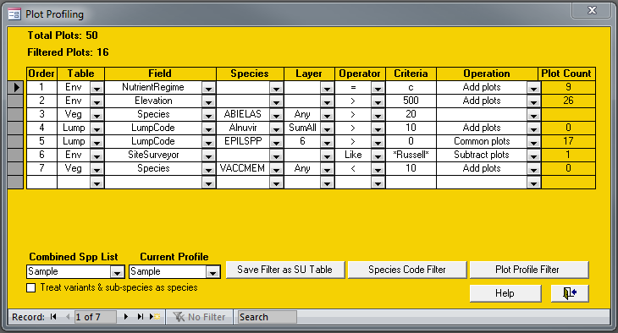
Columns
Order – the Order column accepts integers and instructs the program of the order in which you wish to execute your criteria. This is a very important part of defining a profile because some operations are based on the results of earlier rows.
Table – enter the table that you want to use as the basis of the rest of your criteria. The choices here are Env, Veg, and Lump.
Field – based on your choice of table you will be presented with a list of compatible fields. In the case of selecting Env as your Table, the list will contain a list of all the environment table fields. Selecting the Veg table will result in Species as your only option and likewise with selecting Lump where the only choice will be LumpCode.
Species – this column will only be used when you select either the table Veg or Lump and the Field as Species or LumpCode. The species codes available when you click the pull-down list will be based on either the species in your current project or your combined species list. Using the combined species list in conjunction with the “Treat variants & sub-species as species” will be covered in more detail below.
Layer – again, this column will only be used when you select either the table Veg or Lump and the Field as Species or LumpCode. The choices here are either SumAll, SumA, SumB, Any, or individual layers 1 through 7. SumAll will cause the operator and criteria tested against the summed cover of layers 1 to 7. SumA will use the sum of layers 1 to 3 and SumB will be the sum of layers 4 and 5. The Any choice will cause the program to check all the layers for a cover that satisfies your criteria. Selecting an individual layer will restrict the search to just that one layer.
Operator – selections will depend on whether your table selection is Env, Veg, or Lump. For Veg table selections the choices are =, >, < and do perform exactly as you would assume. For Env you will get to choose from =, >, <, Like, Not Like. The first three choices are obvious in function, but the last two can be powerful operators when used with the wildcards ? and *. The ? wildcard can replace any single character while the * wildcard can replace a string of characters.
Criteria – here is where you enter the actual value, code, string, or partial string you wish to match. VPro does its best to ensure data types are properly converted, but with poor data will come poor results.
Operation – choices here are Add plots, Subtract plots and Common plots. The function of these choices will become clear when we work through the example above.
Plot Count – this column is not editable and is used by the program to display the results of each row after it is executed. A blank row would indicate there was a problem in executing that row.
Other Adjustable Features
Along the bottom you will find two drop-down boxes, Combined Spp List, and Current Profile. You will use these boxes to select, attach and create the respective tables. The check-box option in the lower-left corner is where you can choose to treat variants and sub-species as species. Note that selecting both a combined species list and the treat variants and sub-species as species option will cause VPro to create a hybrid lump table containing both lists.

Row-By-Row Walkthrough
Once you click the Plot Profile Filter button, the form will start to update as it steps through your instructions. The first item to change will be the Total Plots indicator in the upper-left portion of the form; in this case it found and displayed 50 total plots. As mentioned before, your instructions will be processed in the order you have specified in the Order column.
In the first row we’ve instructed the program to find within all 50 plots, all the plots with the NutrientRegime field set to c. It found 9 plots and added that to our list. The Filtered Plots indicator in the upper-left portion of the form will now indicate 9.
The second row asks for all the plots where the elevation is greater than 500 meters be added to our list. It found 26 plots and we now have the Filtered Plots indicating that there are 35 plots in our list.
The third row contains an error. Someone forgot to specify the Operation to be performed on our list. VPro politely informs you of the omission but will forge ahead ignoring this row. Our Filtered Plots indicator remains at 35 plots.
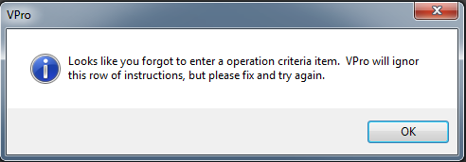
In the fourth row we’ve asked for all the species in the LumpCode ALNUVIR to be summed by plot and across all 7 layers. All we asked for was a cover > 10% but no plots were found that were not already included in the previously filtered plots. The Filtered Plots remains at 35.
In the fifth row we are again using a LumpCode, this time EPILSPP, to find plots where the cover in layer 6 is greater than 0%. This time the specified operation is Common plots, causing the program to look for these criteria only in the 35 previously filtered plots. It found 17, now our Filtered Plots tally sits at 17.
In row six we go back to the environment table to find and remove all plots that were surveyed by anyone with Russell in their name. Thankfully he’d only surveyed one plot so we removed it from our list. Our Filtered Plots count is now 16.

In row seven we look for VACCMEM in any layer where the cover is less than 10% and we specify to add these plots. Now we start to feel suspicious when the Plot Count comes up with zero. We go into the data and we find that there were indeed two plots that matched that criterion. What gives? Same as the fourth row, no plots were found that were not already included in the previously filtered plots. So, our grand total sits at 16 plots.
VPro now builds a filter from this plot list and applies it to the data entry form. If the list is too long, and that happens often with large databases, you will be prompted to save it to a site unit table.
A couple other buttons of note at the bottom of the form, Species Code Filter filters just by species names, and Save Filter as SU Table will save the latest filter to a new SU table and if you have a current site unit table, it will use your previous unit assignments when creating the new table.
Looking for Nulls
You can check for null values in the environment table. The caveat being that the profiler will ignore any operator you insert. In the example below, plots with zones MH or BWBS that have no date are selected in steps 1 to 3. In step 4 all plots that are missing moisture regime are removed.
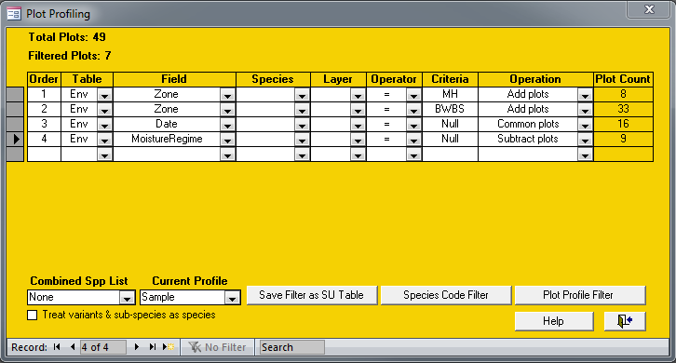
If you have any features you would like to see added, please send a note to Will MacKenzie at Will.MacKenzie@gov.bc.ca

